Resume
Mrs. Jeklin Ravikant Parmar

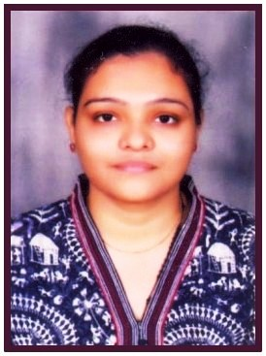
Address: - A-5, IshanPark Society,
Opp. Gunatit Nagar Society,
Pavanchakki Road,
Nadiad. 387002 (Kheda-Gujarat)
Mobile num: - 9714422138
Email Id: - jeklinmacwan@gmail.com

Career Objective: -
To associate with an organization for providing my talent and achieving the professional excellence through hard work, sincerity and integrity.

[Cite your source here.]

Personal Profile
- Date of Birth: - 24th August 1991
- Gender: - Female
- Religion: - Christian
- Marital Status: - Married
- Nationality: - Indian
- Language Known: - English, Hindi & Gujarati
- Hobbies: - Travelling & Music.
- Computer Skills: - Basic & M.S Office
- Professional Attribute: - Ability to work hard & time punctuality.

Educational Qualifications
S.R No. | Name of Exam | Board/University | Month & Year | Percentage
1 | SSC | GSHSEB | March-2006 | 67.14%
2 | HSC | GSHSEB | March-2008 | 62.43%
3 | BSW | Sardar Patel University | March-2011 | 67.30%
4 | MSW | Sardar Patel University | April-2013 | 77.60%
5 | CCC | BAOU | July-2016 | 64.25

Professional Experience
S.R No. | Organization | Designation | Duration
1 | GVKEMRI | Counselor Officer | 1st Nov 2013 to 15th Oct 2014
2 | DISMU | ECCE Co-odinator | 27th Oct 2014 to till date...

Field Work Experience
- Worked at Healing Touch NGO (Slum Development) Maitri NGO (For specially challenged children), Jeevan Deep NGO (For HIV/AIDS positive people) as social worker
- Worked at Rural level for one year (Pij village)
- Worked at Hospital level (Shri Krishna Medical Hospital),(Hospital for Mental Health)

Training, camps
- First Aid training of 1 day at 108 Emergency Management centre Ahmedabad
- Praticipated in NSS Camp of 6 days at Hanumanpura, Anand.
- Participated in Rural Camp of 6 day at Sumeru village, Karjan-Vadodara (During 2nd Sem MSW- 2012).
Project And Research
- Personal Project on a subject “Awareness Regarding Breast Cancer anomg Women”.
- A Personal Dissertation on HR BRANDING

References
Mrs.Jigisha Pathak  Program Officer  ICDS Kheda Jilla Panchayat  Nadiad  Mo:- 9904315263  Email – po.icds.kheda@gmail.com | Mrs.Joytsnaben Patel  Child Development Project Ofiicer  Kathlal  Mo:- 9909236031  Email – cdpoicdskathlal@gmail.com

I hereby certify that the above Information are true and correct to the best of my belief...

Jeklin Parmar
(Nadiad)

